

**VOL 2 NO 1: JANUARY, 2025**

**AN OPEN ACCESS PEER-REVIEWED JOURNAL**

**PATTERN OF DEPRESSIVE DISORDERS AND PERCEIVED FAMILY SUPPORT AMONG ADULT PATIENTS ATTENDING THE GENERAL OUT-PATIENT CLINICS OF A SOUTH-EASTERN NIGERIA TERTIARY HOSPITAL.**

**Mbatuegwu CU1, Egwim JI2, Onuoha F3, Mbatuegwu AI4 and Onyechere CJ5**

**Affiliations:** 1Department of Family Medicine, Federal Teaching Hospital Owerri, Imo State, Nigeria

2Department of Family Medicine, Federal Teaching Hospital Owerri, Imo State, Nigeria

3Department of Family Medicine, Federal Teaching Hospital Owerri, Imo State, Nigeria

4Department of Ophthalmology, Federal Teaching Hospital Owerri, Imo State, Nigeria

5Department of Medicine, Military Hospital Ikoyi, Lagos State

Citation: Mbatuegwu CU, Egwim JI, Onuoha F, Mbatuegwu AI and Onyechere CJ (2025) Pattern of depressive disorders and perceived family support among adult patients attending the general out-patient clinics of a South-Eastern Nigeria tertiary Hospital. Frontline Professionals Journal, 2(1), 202– 220

**ABSTRACT**

**Background:** Depression in South-Eastern Nigeria is under-diagnosed and poorly managed while weakening traditional support systems exacerbate this issue.

**Aim:** This was to investigate the prevalence of depression in the Federal Teaching Hospital Owerri (FTHO) General Out-patient Clinics while examining the relationship between perceived family support (PFS) and depression.

**Methodology:** A cross-sectional study was conducted on 370 individuals using an interviewer administered, questionnaire including the PHQ-9 and MSPSS family subscale tools.

**Results:** The study found a 17.3% prevalence of depression, a mean PFS score of 16.34 ±4.59, where major depression prevailed (69.2%) when PFS score was below the mean.

**Conclusion:** There was a negative relationship pattern between depression severity and PFS.It is urged that an improvement in PFS could protect mental health.

**INTRODUCTION**

Depression is a multifaceted ailment affecting various aspects of well-being, globally recognized by the World Health Organization's Primary Health Care initiative (WHO, 2019). Depression alone (minus any other chronic illness) had an overall prevalence of 3.2% (GBD, 2019).It ranges from transient feelings to persistent clinical syndromes and is a leading global cause of disability, incurring substantial economic costs (GBD, 2019). Social relationships, particularly perceived family support (PFS), significantly impact its morbidity (kato,Tateno,2014). Depression's cyclical nature and link to neurotransmitter deregulation underscore its complexity. Recognizing it as a medical condition is crucial, considering its recurrent nature and association with social support absence (Kato, 2014; kupfer *et al,* 1996; WHO, 2017; Ho;t-Lunstead *et al*,2010).

In the Family Systems Theory, families act as quasi-homeostatic mechanisms, buffering disruptions in individuals' systems (Minuchin,1974). Urbanization weakens kinship ties, leaving members susceptible to stressors. Inadequate family support correlates with increased depressive symptoms, complicating healthcare management. Psychosocial factors linked to depression impact chronic disease progression. Family support, especially PFS, plays a vital role in regulating emotions, cognitions, and behaviours, acting as a stress buffer. Diagnosing depression relies on clinical assessment tools (APA, 2013). Imperfect depression rating scales, especially in the geriatric population, pose challenges. Treatment goals aim for full symptom remission and optimal functioning through pharmacotherapy, psychotherapy, and family therapy (WHO, 2017). Antidepressants targeting neurotransmitters offer relief, with the PHQ-9 guiding interventions based on severity (WHO,2017). Depression ranks high among primary care diseases globally and is anticipated to rise (Ohaeri, Odejide, 1994). Early detection in family medicine clinics is crucial for intervention. The study aimed to explore depression severity patterns in family medicine clinics, emphasizing the role of perceived family support. Despite the prevalence of depression in Owerri and Southeastern Nigeria, there's a lack of local information, making this study significant for future research and policy development. Depression's global impact is substantial, predicted to surpass other health issues, creating economic and sociological burdens. Despite this, mental health funding remains disproportionately low (Saxena, 2005).

Depression's detrimental effects on judgment can lead to suicidal thoughts, emphasizing the importance of addressing it as a public health priority. International studies highlight varying prevalence rates, with factors like gender, education, and cultural nuances influencing presentation (DGP, 1993; Moussavi *et al,* 2007; Kupfer *et al,* 1996; Riolo *et al*,2001; Zhang *et al,* 2012; Patel *et al*,2001; Schneider *et al*,2018). Reports indicate a lifetime prevalence of major depression at 9.7% in 2002 and 4.9% for the twelve months preceding 2004 (Patel *et.al*, 2001). Depression in African women in South Africa was associated with factors such as unemployment, poverty, overcrowding, high crime levels, lack of services, and sexual abuse. In Nigeria, depressive disorders contribute significantly to the disease burden, with individuals more likely to seek care in primary care or general practice clinics than psychiatric services (Adewuyo *et.al* 2013). Studies in the South-west of Nigeria observed a lifetime prevalence of depression among the elderly (65 years and older) at a staggering 26.6% (Adewuyo *et.al*, 2013).Most of these lifetime cases received no treatment, with predictors of treatment reception including socio-economic status and urban residence (Adewuyo *et.al*, 2013). An additional study in Oyo State, Nigeria, found an overall prevalence of depression at 5.2%, with higher rates among women and adolescents (Adewuyo *et.al* 2009).

In some regions, such as Southeastern Nigeria, the prevalence of depression is alarmingly high among certain populations, such as HIV/AIDS patients (21.3%) and medical students (23.3%), especially those aged 16 to 20 years (Egbe *et al*, 2017; Ndu AC,2011). Depression is also a significant risk factor for suicidal behaviour among pre-adolescents (Gariepy *et.al* 2016), highlighting the need for effective prevention and treatment strategies Family support, alongside other social support forms, significantly influences mental health outcomes (WHO, 2019). Positive effects include stress reduction, enhanced coping skills, improved self-esteem, and treatment adherence. Interventions addressing the consequences of insufficient social support on mental health have shown positive outcomes, emphasizing the need for family involvement. [Research has shown that the family can affect the development, onset, and maintenance of psychological problems, as well as the recovery and well-being of individuals with mental health issues](https://www.scribbr.co.uk/referencing/vancouver-style/) Small, 2011; Kyzar *et al,,* 2012). [This is especially relevant in Africa, where extended family systems provide a strong source of social support and care for people with mental health needs](https://www.scribbr.co.uk/referencing/vancouver-style/) (Ohaeri, 2003).

[Family support can have various positive effects on health outcomes, such as reducing stress, enhancing coping skills, improving self-esteem, and promoting adherence to treatment](https://www.scribbr.co.uk/referencing/vancouver-style/) (Cohen, Willis, 1985). [For instance, a study on diabetic patients found that family support was inversely related to fasting plasma glucose levels, indicating that family involvement can improve disease management and control](https://www.scribbr.co.uk/referencing/vancouver-style/) (Rosland *et al*, 2012; House,1981; Uchino, 2006; Fraseure-Smith et al, 2000; Da Costa et al, 2012). Historical studies like Olson and Wallace's associate increased family conflict with higher depression levels in adolescents (Olsen, 2002). Thompson et al. demonstrate the protective role of perceived social support, indicating its absence exacerbates the link between low self-efficacy and suicidal ideation (Thompson et al, 2007). Monroe and Windle's work establish the heightened risk of depression with deficits in social support, emphasizing age and gender-based distinctions (Monroe, Windle, 1992; Monroe, Windle, 2001). Assessing subjective experiences like perceived support poses challenges, utilizing tools such as the PHQ-9 and self-report measures like the MSPSS. Colarossi and Farmer's studies emphasize the multifaceted nature of social support captured by various instruments (Calarossi, 2001; Farmer, 1996).

The study recognizes how marital characteristics can shape perceptions of support and explores diverse tools for their suitability in assessing this specific aspect. These include: Arizona Social Support Interview (ASSI); Family Crises Oriented Personal Evaluation Scales (FCOPES); Dunst Family Resource Scale (FRS); Family Resource Scale (FRS revised); Dunst Family Support Scale (FSS); Duke-UNC Functional Social Support Questionnaire (DUFSS); Medical Outcomes Study: Social Support Survey (MOS-SSS); Multidimensional Scale of Perceived Social Support (MSPSS); Norbeck Social Support Questionnaire (NSSQ); Perceived Social Support Scale (PSSS);

The Social Provisions Scale (SPS); Social Support Questionnaire (SSQ). The MSPSS, selected for its focus on family support, aligns with the study's central objective. This was in addition to its reliability, validity, and brevity. The complex interplay between family support, social support, and depression is evident. Various instruments, including the MSPSS, highlight the intricate transactional process involved in active support networks. Utilizing these networks and addressing support system gaps can significantly impact mental and physical well-being globally.

**MATERIALS AND METHODS:**

The study was conducted at the General Outpatient Clinic (GOPC) of FTHO, a tertiary health institution located in Imo State, Nigeria. The clinic, managed by the Family Medicine Department, serves as the primary care point for most adolescent and adult patients in the region. FTHO, with a patient population of about 3 million people, offers various services across so many medical specialties, serving as a referral centre for the State and its neighbours.

The study recruited subjects aged 18 and above from the GOPC. It employed a hospital-based, cross-sectional analytic design. Ethical considerations were ensured through confidentiality measures, informed written consent, and approval from the FTHO research and ethical committee.

The sample size of 370 was determined using standard formulas, considering the prevalence of depressive illness. A systematic random sampling method was employed for participant recruitment, and data were collected using a pre-tested questionnaire incorporating the Patient Health Questionnaire-9 (PHQ-9) and the Multidimensional Scale of Perceived Social Support (MSPSS). The PHQ-9 assessed depression, and the MSPSS measured perceived social support.

The study defined major depressive disorder based on DSM-IV criteria and PHQ-9 scores. Data analysis involved sorting, coding, and using SPSS software. Results were presented using frequency tables and charts. Qualitative variables were expressed as proportions, and summary indices were used for quantitative variables. Statistical tests, including t-tests and chi-square tests, were employed to evaluate differences and associations between variables.

The study duration was approximately twelve weeks, including data collection, collation, analysis, and reporting. The investigator bore the cost of the study, with some support from FTHO management.

**Results:**

The study was carried out over a three-month period. 370 patients were recruited, and all the data acquired was analysed using the IBM® SPSS® Statistics version 20. The result has been displayed in tables and charts.

**Table 2 Socio-demographic characteristics of study group**

|  |  |  |
| --- | --- | --- |
| **Characteristics** | **Frequency** | **Percentage (%)** |
| **AGE GROUP (YEARS)**  <30  30-39  40-49  50-59  60-69  70 and above | 81  64  96  69  32  28 | 21.9  17.3  26.0  18.6  8.6  7.6 |
| **GENDER**  Male  Female | 120  250 | 32.4  67.6 |
| **MARITAL STATUS**  Single  Married  Separated  Divorced  Widowed | 91  247  6  0  26 | 24.6  66.8  1.6  0  7.0 |
| **LEVEL OF EDUCATION**  No Formal Education  Primary  Secondary  Tertiary | 14  38  103  215 | 3.8  10.3  27.8  58.1 |
| **OCCUPATION**  Unemployed  Student/Apprentice  Civil Servant  Retired  Professional  Farmer/Petty trader  Business Executive  Others | 16  95  92  30  32  67  12  26 | 4.3  25.7  25.0  8.1  8.6  18.1  3.2  7.0 |
| **RELIGION**  Christianity  Islam | 370  0 | 100  0 |

**Table 2** in the previous page gives the socio-demographic distribution of the study group with respect to the parameters highlighted in uppercase.

**Table 3 Age group and gender relationships**

|  |  |  |  |  |
| --- | --- | --- | --- | --- |
| **Sex** | | **Age Group (Years)** | | **Total** |
| 18-30 (Youth) | ≥31 (Older adults) |
|  | **Male** | 25 | 95 | 120 |
| **Female** | 66 | 184 | 250 |
| **Total** | | 91 | 279 | 370 |

X2= 1.35; df= 1; 0.244

**Table 3** shows that out of the 250 females, 184 (73.6%) were older adults aand 66 (26.4%) were youth. Of the males who were 120 in number, 95 (79.2%) were older adults while 25 (20.8%0 were youth. 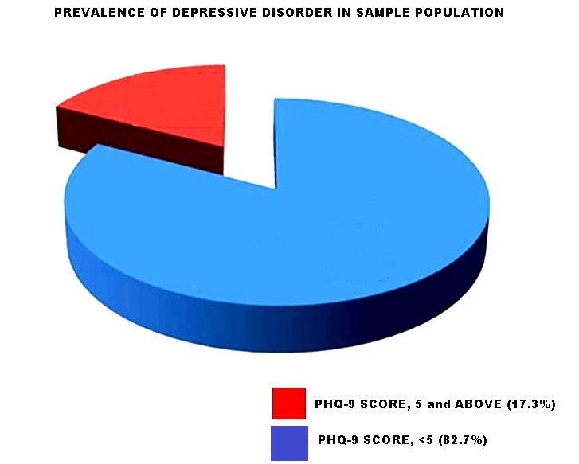

**Fig 1 Prevalence of depressive disorder in study population**

**Fig 1** shows the prevalence of depressive disorder in the sample population. Out of 370 people studied, 306 were free from any form of depressive disorder, while 64 had depressive disorder.

**Table 4. Gender prevalence of depression**

|  |  |  |  |  |
| --- | --- | --- | --- | --- |
| **PHQ-9 Score** | | **Gender** | | **Total** |
| **Male** | **Female** |
|  | <5 | 96 | 210 | 306 |
| ≥5 | 24 | 40 | 64 |
| Total | | 120 | 250 | 370 |

X2= 0.907; df= 1; p= 0.341

**Table 4** shows that 40 of the 250 females from the study sample had depressive disorders.

**Table 5. Depression severity with respect to gender**

|  |  |  |  |  |
| --- | --- | --- | --- | --- |
| **Gender** | | **Depression severity** | | **Total** |
| **Minor** | **Major** |
|  | **Male** | 12 | 12 | 24 |
| **Female** | 16 | 24 | 40 |
| **Total** | | 28 | 36 | 64 |

X2= 0.610; df= 1; p= 0.435

**Table 5** shows the relationship between depression severity and gender.

|  |  |  |  |  |
| --- | --- | --- | --- | --- |
|  | | **Depression severity** | | **Total** |
| **Minor** | **Major** |
| **Age Group (Years)** | **Youth**  **Older adults** | 14  14 | 10  26 | 24  40 |
| **Total** | | 28 | 36 | 64 |

**Table 6. Depression severity with respect to age**

X2= 3.319; df= 1; p= 0.69

**Table 6** shows that the prevalence of major depressive disorder is higher (65.0%) among older adults in contradistinction to its prevalence rate (41.7%) among the youth.

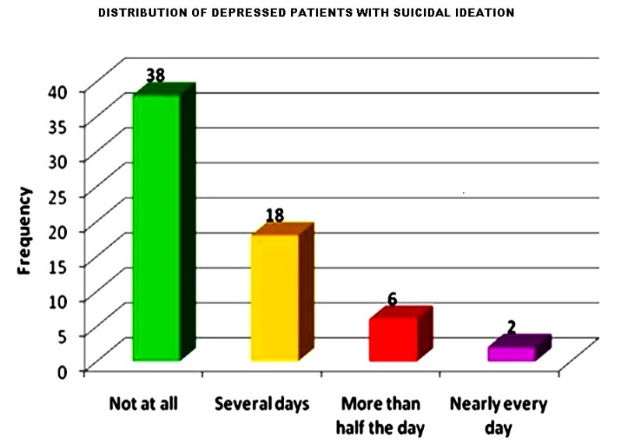

**Fig 2 Frequency of suicidal ideation among patients with depressive disorder**

**Fig. 2** shows the threat of mortality from depressive disorder in the study population. Of the 64 persons with depressive disorder, 38 (59.4%) were free of any suicidal ideations. However, the remaining 26 (40.6%) had entertained suicidal ideations.

**Fig 3 Level of PFS in the study population.**

**15%**

85`%

**Fig. 3** shows the frequency distribution of PFS score among the participants grouped with reference to the mean PFS score. There were 56 people (15%) with a PFS score below the mean. Those with PFS score up to the populations mean and above it numbered 314 (85%).

**Table 7 PFS variations with respect to age and gender**

|  |  |  |  |  |  |  |  |  |  |  |
| --- | --- | --- | --- | --- | --- | --- | --- | --- | --- | --- |
|  | | **Sex** | **Age Group (Years)** | **Frequency** | | **Mean** | **Standard Deviation** | | **p-Value** | |
| **Male**  **Female** | **PFS Score**  **PFS Score** | | 18-30  ≥31  18-30  ≥31 | | 10  14  14  26 | 14.80  17.57  13.86  17.62 | | 5.22  2.77  5.25  4.24 | | 0.10  0.02 |

**Table 7** shows that there is a statistically significant association between age group and the PFS score among females in the depressed population. The older adult females recorded a higher PFS mean score (17.62 ±4.24) as against their younger counterparts who recorded the lower PFS mean score of 13.86 ±5.25, (p= 0.02).

The same ordering is observed among the males in this population, but the distribution was not statistically significant (p= 0.10).

**Table 8** **VARIATIONS OF DEPRESSION SEVERITY, PFS AND MARITAL STATUS**

|  |  |  |  |  |
| --- | --- | --- | --- | --- |
|  | **Category** | **Frequency** | **Mean** | **Std. Deviation** |
| **Perceived Family Support**  **(MSPSS-Fa Score)** | **Single**  **Married**  **Separated**  **Widow**  **Total** | 22  34  2  6  64 | 15.73  17.35  19.00  12.00  16.34 | 4.94  3.70  0.00  6.20  4.59 |
| **Depression Severity Score**  **(PHQ-9 Score)** | **Single**  **Married**  **Separated**  **Widow**  **Total** | 22  34  2  6  64 | 9.18  11.41  10.00  15.00  10.94 | 5.18  4.38  0.00  7.16  5.08 |

**Table 8** shows that the widows had the lowest PFS mean score and the highest depression severity mean score. The pattern of the PFS score was statistically significant (p= 0.040) but the depression severity score pattern held no statistical significance (p= 0.074)

**Fig 4. Relationship between depression severity and PFS**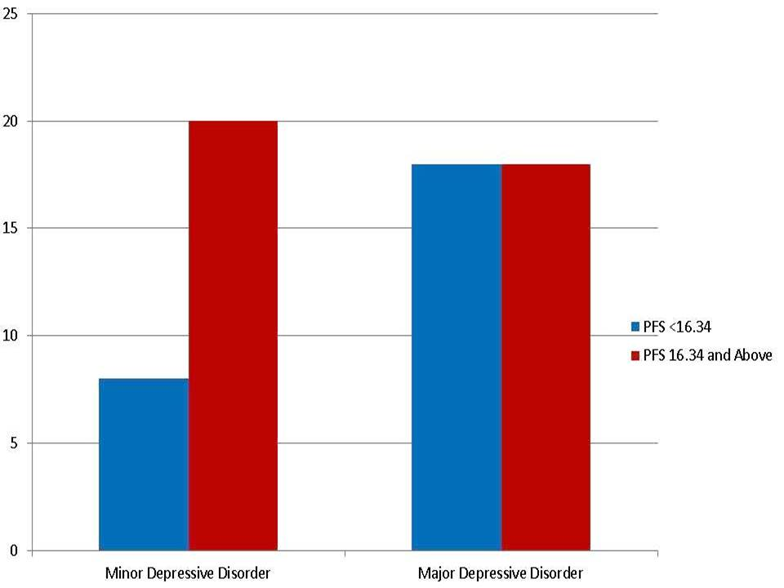

**Fig 4** shows that for those with PFS score up to and above the mean score of 16.34, the greater number of 20, have minor depressive disorder. On the other hand, for those with PFS score below the mean score, the number with major depressive disorder rises much higher from 8 to 18 than those in their group with minor depressive disorder. These relationships were without statistical significance (*x*2= 2.998; df= 1; p=0.083).

**DISCUSSION**

In the sampled population of 370 patients, 81 (21.9%) were <30 years of age, 60 (16.2%) were ≥60 years and the rest were between 30 and 59 years of age. There were more females than males in a ratio of 25:12. The married patients were in the majority, numbering up to 247 (66.8% of the study population). Some of the participants were single, some widowed or separated but none was divorced. The level of education was equally high with 85.9% of the study population having achieved more than primary school education. The unemployed were in the minority, 4.3% of the 370 participants.

A re-grouping of the population based on age resulted in a youth to older adults’ ratio of 91:279 (1:2.97). In Table 3, out of 91 youth, 66 were female (72.5%) and 25 male (27.5%). That there were fewer youth (both male and female) seen in this distribution was, however, not a feature of statistical significance (p= 0.24). This disparity could have resulted from a difference in health-seeking behaviour and hypothetical predominance of ill health with advancing age. The prevalence of major depressive disorders is shown in Table 6 to be higher (36 - 56.3%) than minor depressive disorders (28 - 43.8%) in the study population. This, however, was of no statistical significance (p= 0.069). [As seen in Fig 1, the prevalence of depressive disorder in the study population was 17.3% among adult patients aged 18 years and above. This is higher than the global rates (GBD, 2019) but lower than the rates in many individual nations](https://www.mentalhelp.net/depression/article-references/) (Wu *et.al*,2024). The depiction of Table 4 is a female prevalence rate for depressive disorder which is 16.0%. The males who were 120 in number had 24 of them with depressive disorder, giving a male prevalence rate of 20%. The female prevalence rate was observed to be less than the male prevalence rate for depressive disorders. Among the 24 males with depression, distribution was equivocal between minor and major depression (ratio of 1:1). On the other hand, there were more women with major depressive disorder than those with minor depressive disorder at a ratio of 3:2 (24 to 16 females). These differences were not statistically significant. From a different perspective, among the 64 with depressive disorders the percentage of females is 62.5% and the males make for 37.5%. Therefore, the study population had more women with depressive disorder than men at a ratio of 1:1.67. According to a comparative National Health and Nutrition Examination Survey, conducted by the National Center for Health Statistics, 8.1% of American adults aged 20 and over had depression in each 2-week period between 2013-2016 (CDC, 2018). This meant that the women (10.4%) were almost twice as likely as the men (5.5%) to have depression. [The study also found that the level of perceived family support, had 85% of the sample population above the mean score. There was a higher PFS for the old more than the young, and this relationship was statistically significant among the females](https://www.mentalhelp.net/depression/article-references/). There is an equal distribution of minor depression in the two age groups but older adults have a higher frequency of major depression (72.2%).

[Despite this the severity pattern in the study group gave a predominance of major depressive disorder among females and older adults](https://www.mentalhelp.net/depression/article-references/). Though overall evidence is highly consistent and in support of the notion that social support is an important protective factor against depression, the sources of social support that were most protective of depression varied across the life periods (Kato, Tateno, 2014). For those with a higher PFS score there was little difference in severity from minor to major depression. However, for the population with the lower PFS, there was a spike in depression severity levels from minor to major depression. This apparent negative influence of poor PFS on depression severity was resonated by some earlier study findings(Kato, Tateno, 2014). [Though this spike was very suggestive of a worsening degree of depression with respect to prevailing PFS, the statistical significance of the totalled results did not support the hypothesis which posits that the severity pattern of depressive disorders is influenced by the level of family support as perceived by patients attending the GOPC of FTHO](https://www.mentalhelp.net/depression/article-references/).

Depression is a real illness and carries with it a high disease burden. Family suffering and lost work productivity compound the problems posed by its prevalence. [Yet, depression is a highly treatable illness](https://www.mentalhelp.net/depression/article-references/). [The importance of social relationships in the treatment of diseases and the maintenance of health and well-being has drawn the attention of scientists and practitioners across many behavioural science and medical disciplines](https://www.mentalhelp.net/depression/article-references/). [Prospective population studies have established associations between measures of interpersonal relationships and mortality, psychiatric and physical morbidity, and adjustment to and recovery from chronic diseases](https://www.mentalhelp.net/depression/article-references/). According to a study, among those with depression, the group whose PFS score equals or is above the population’s mean score had a greater percentage of their population (52.6%) having minor depression while the group whose PFS score did not get up to the mean score had their greater percentage (69.2%) suffering major depression. [However, this pattern was not statistically significant](https://meridian.allenpress.com/mhc/article/5/6/271/127791/The-role-of-methylphenidate-in-depression) (Kato,Tateno,2014). Notwithstanding this, a previous body of evidence of a cross-sectional nature had shown statistical significance in that association. The cross-sectional design of comparative studies, lacking in temporal association of variables, precluded an inference of the direction of association between social support and protection from depression. In other words- which comes before the other ( Boudrreault et al, 2013; Holahan, 1995; Ex et al, 1998; Carloson, Mj, 2006; Branje et al, 2007, Kennely et al, 1989; Stafford et al, 2011; Pettit et al, 2011, Walen et al , 2000)

[Interventions designed to alter the social environment and the individual’s transactions with it have been successful in facilitating psychological adjustment, aiding recovery from traumatic experiences, and even in extending life for persons with serious chronic disease](https://bmcpsychiatry.biomedcentral.com/articles/10.1186/s12888-024-05517-5) (Kupfer et,al 1996). [In the case of mental health, social support is thought to maintain regulation of response systems of emotions, cognitions and behaviour, preventing extreme responses associated with dysfunction](https://bmcpsychiatry.biomedcentral.com/articles/10.1186/s12888-024-05517-5) (Kupfer *et.al*, 1996). [This regulation occurs through communication of what is expected, of appropriate norms, of rewards and punishments, and through the provision of coping assistance](https://bmcpsychiatry.biomedcentral.com/articles/10.1186/s12888-024-05517-5) (Kupfer *et.al*,1996). [Perceived availability of social resources is most often found to act as a stress buffer](https://bmcpsychiatry.biomedcentral.com/articles/10.1186/s12888-024-05517-5) (Kupfer *et.al*, 1996). However, it is worthy of note that increases in social contact, social interaction, and the provision of social resources are not always health protective. [Those with more close friends and family members have more opportunities for interpersonal conflict than their relatively isolated counterparts](https://bmcpsychiatry.biomedcentral.com/articles/10.1186/s12888-024-05517-5) (Kupfer *et.al* 1996). [Moreover, the provision of aid in the face of a crisis can have detrimental effects on a recipient when the source or type of aid is inappropriate](https://bmcpsychiatry.biomedcentral.com/articles/10.1186/s12888-024-05517-5) (Kupfer *et.al* 1996).

**CONCLUSION**

The study highlights the complex interplay between perceived social support, mental health, and family dynamics. Conducting a more extensive study within a broader community could provide valuable insights. Examining a diverse range of individuals may reveal patterns that were not evident in the current sample. In summary, while statistical significance wasn't achieved, the study underscores the need for holistic approaches to mental health, emphasizing family support and considering broader social contexts. Continued research in this area can inform effective interventions and policies.

**RECOMMENDATIONS**

It remains crucial to revitalize family support systems. Especially in countries like Nigeria, where political challenges often lead to poor social welfare, strengthening family roles can contribute significantly to overall well-being. Engaging various stakeholders, including religious and social groups, can enhance social support networks. These networks play a vital role in promoting and safeguarding mental health within families.

The study's identification of marital distress as a risk factor for major depression underscores the importance of addressing relationship dynamics. Behavioural approaches, such as modifying verbal interactions and implementing behavioural contracts, may be more effective than standard drug treatments. Considering the influence of social resources, further research is needed to explore how perceived family support impacts depression and its severity. Additionally, investigating the influence of occupation, education, and marital status on both perceived family support and depression can provide valuable insights.

**LIMITATIONS**

The study was conducted at a single tertiary hospital in Imo State, Nigeria. This limits the generalizability of the findings to other more heterogenous populations and settings. A larger, more diverse sample across different regions would strengthen the generalizability and external validity. The cross-sectional design provides a snapshot of the relationship between variables at a single point in time. The lack of temporal cannot establish causality or determine the direction of the association between social support and depression. Longitudinal studies would be better suited to explore these relationships over time. While the PHQ-9 and MSPSS are widely used and validated tools, they rely on self-reported data even when interviewer-administered. This could make the data subject to recall bias and social desirability bias.Incorporating other measures, such as objective clinical interviews and assessments, could enhance the validity of the findings.

**ACKNOWLEDGEMENT**

Thanks go to the management and ethical committee of the Federal Teaching Hospital Owerri, co-researchers and assistants. The research holds an indebtedness to the participants whose hospital waiting time was sacrificed for the actualization of this survey.

**REFERENCES**

Adewuya, A. O., Makanjuola, R. O., Adegbile, A. O., Ola, W. O., Olusola, B. A., Aina, K. O., et al. (2013). Burden of depression and its predictors among older adults in Ibadan, South-West Nigeria: A community-based study. International Journal of Geriatric Psychiatry, 28(3), 242-250.

Adewuya, A. O., Salami, O. A., Olusola, B. A., Aina, K. O., Ola, W. O., Makanjuola, R. O., et al. (2009). Prevalence and associated factors of depression in a rural community in southwest Nigeria. International Journal of Social Psychiatry, 55(3), 206-212.

American Psychiatric Association. (2013). Diagnostic and statistical manual of mental disorders (5th ed.). https://doi.org/10.1176/appi.books.9780890425596

Centers for Disease Control and Prevention. (2023). Depression. Centers for Disease Control and Prevention. https://www.cdc.gov/nchs/products/databriefs/db303.htm

Cohen, S., & Wills, T. A. (1985). Stress, social support, and the buffering hypothesis. Psychological Bulletin, 98(2), 310-357.

Da Costa, T. M., Pinto-Neto, A. M., Conde, D. M., et al. (2012). A randomized clinical trial on the effects of a psychosocial intervention on depression in perimenopausal women. Journal of Psychosomatic Obstetrics & Gynecology, 33(1), 1-8

Depression Guideline Panel. (1993). Clinical practice guideline for major depressive disorder: Evidence report and recommendations. Psychopharmacology, 107(S1), 1-69.

Egbe, C. O., Dakum, P. S., Ekong, E., et al. (2017). Depression, suicidality, and alcohol use disorder among people living with HIV/AIDS in Nigeria. BMC Public Health, 17, 542.

Frasure-Smith, N., Lespérance, F., Gravel, G., et al. (2000). Social support, depression, and mortality during the first year after myocardial infarction. Circulation, 101(16), 1919-1924.

Gariépy, G., Honkaniemi, H., & Quesnel-Vallée, A. (2016). Social support and protection from depression: Systematic review of current findings in Western countries. British Journal of Psychiatry, 209(4), 284-293.

GBD 2019 Diseases and Injuries Collaborators. (2019). Global burden of 369 diseases and injuries in 204 countries and territories, 1990–2019: A systematic analysis for the Global Burden of Disease Study 2019. The Lancet, 396(10258), 1204–1222.

Holt-Lunstad, J., Smith, T. B., & Layton, J. B. (2010). Social relationships and mortality risk: A meta-analytic review. PLoS Medicine, 7(7), e1000316. <https://doi.org/10.1371/journal>. pmed. 1000316

House, J. S. (1981). Work stress and social support. Addison-Wesley.

Kato, T., & Tateno, M. (2014). Social support and depression: A review. Psychiatry and Clinical Neurosciences, 68(10), 783–793.

Kessler, R. C., Berglund, P., Demler, O., Jin, R., Koretz, D., Merikangas, K. R., Rush, A. J., Walters, E. E., & Wang, P. S. (2003). The epidemiology of major depressive disorder: Results from the National Comorbidity Survey Replication (NCS-R). JAMA, 289(23), 3095–3105.

Kupfer, D. J., Frank, E., & Wamhoff, J. (1996). Mood disorders: Update on prevention of recurrence. In D. J. Kupfer & F. E. Bloom (Eds.), Psychopharmacology: The fourth generation of progress (pp. 1139–1150). Raven Press.

Kyzar, K., Turnbull, A., Summers, J. A., et al. (2012). The relationship of family support to family outcomes: A synthesis of key findings from research on severe disability. Research and Practice for Persons with Severe Disabilities, 37(1), 31-44.

Mental Health and Substance Use, World Health Organization. (2019). Primary health care and mental health. World Health Organization. https://www.who.int/teams/mental-health-and-substance-use/world-mental-health-report

Minuchin, S. (1974). Families and family therapy. Harvard University Press.

Moussavi, S., Chatterji, S., Patel, V., Saxena, S., Rahman, A., Shah, A., & Koyanagi, A. (2007). Depression, chronic diseases, and co-morbidities: Prevalence and associated risk factors in 10/10 countries. PLoS Medicine, 4(6), e245.

Ndu, A. C., Arinze-Onyia, S. U., Aguwa, E. N., et al. (2011). Prevalence of depression and role of support groups in its management: A study of adult HIV/AIDS patients attending HIV/AIDS clinic in a tertiary health facility in South-eastern Nigeria. Journal of Public Health and Epidemiology, 3(4), 182-186.

Ohaeri, J. U. (2003). The burden of caregiving in families with a mental illness: A review of 2002. Current Opinion in Psychiatry, 16(4), 457-465.

Ohaeri, J. U., & Odejide, O. A. (1994). The psychosocial problems of families of depressed Nigerian patients. Social Psychiatry and Psychiatric Epidemiology, 29(2), 68–73.

Patel, V., Abas, M., Broadhead, J., Todd, C., & Reeler, A. (2001). Depression in developing countries: Lessons from Zimbabwe. BMJ, 322(7284), 482–484.

Riolo, S. A., Nguyen, T. A., Greden, J. F., & King, C. A. (2001). Prevalence of depression by race/ethnicity: Findings from the National Health and Nutrition Examination Survey III. American Journal of Public Health, 95, 998-1000.

Rosland, A. M., Heisler, M., & Piette, J. D. (2012). The impact of family behaviors and communication patterns on chronic illness outcomes: A systematic review. Journal of Behavioral Medicine, 35(2), 221-239.

Saxena, S. (2005). Global burden of mental disorders and the need for a new public health approach. The Lancet, 366(9490), 703-710.

Schneider, M., Baron, E., Davies, T., Munodawafa, M., & Lund, C. (2018). Patterns of intimate partner violence among perinatal women with depression symptoms in Khayelitsha, South Africa: A longitudinal analysis. Global Mental Health, 5, e13.

Small, R., Taft, A. J., & Brown, S. J. (2011). The power of social connection and support in improving health: Lessons from social support interventions with childbearing women. BMC Public Health, 11(Suppl 5), S4.

Uchino, B. N. (2006). Social support and health: A review of physiological processes potentially underlying links to disease outcomes. Journal of Behavioral Medicine, 29(4), 377-387.

World Health Organization. (2017). Depression and other common mental disorders: Global health estimates. World Health Organization.

Zhang, L., Xu, Y., Nie, H., Zhang, Y., & Wu, Y. (2012). The prevalence of depressive symptoms among the older in China: A meta-analysis. International Journal of Geriatric Psychiatry, 27(9), 900–906.